Checkpoint Job Performance Solutions for IRS LMSB
A Pilot Program for International Examiners

THOMSON REUTERS
Tax & Accounting

Ruth Apelt
National Sales Manager, Public Sector
(703) 548-0368
ruth.apelt@thomsonteuters.com

Table of Contents

Introduction 3
Checkpoint Job Performance Solutions for LMSB 3
• Checkpoint Research 3
• Checkpoint Analytical Tools 3
• Checkpoint Learning 3
Checkpoint Research Overview 4
Checkpoint Features and Benefits 4
Checkpoint International Tax Research 5
Accounting, Auditing & Financial Reporting Research 8
Checkpoint Analytical Tools Overview 9
International Specialty Tools 9
Other Efficiency Tools Available On Checkpoint 11
Checkpoint Learning Overview 13
What’s New with MicroMash/PASS Online 14
Checkpoint Learning: International Course Examples 15
Checkpoint Learning Approach for IRS LMSB International Agents 18
Thomson Reuters/IRS Learning Partnership 19
Custom Course Screen Shot Examples 20
About Thomston Reuters 21
About The Tax and Accounting Business 22

Introduction

Today’s Internal Revenue Service (IRS) operates in a complex environment that is constantly changing. Challenges include:

- Accelerating globalization and the development of new business models challenge IRS efforts to ensure that all businesses pay the taxes they owe.
- Tax laws that are increasingly complex,
- The expanding role of tax practitioners and other third parties.
- The explosion in technology that has raised taxpayer expectations for new ways to interact with the IRS – and increased security risks, requiring more vigilance.

Though faced with these significant hurdles, studies of international tax systems show that the U. S. system is extremely effective and that the IRS has a highly motivated workforce that clearly understands its mission. The IRS Strategic Plan 2009 – 2013 outlines steps that will enable IRS to continue this high level of performance.

“We will meet the challenges of globalization by improving our expertise and coordinating better with international organizations. We need to excel at both service and enforcement to meet our mission: it isn’t an either/or proposition. To succeed, we will support these goals by investing in two strategic foundations – our people and our technology. We will strive to make the IRS the best place to work in government. We will give our people the technology they need to improve efficiency, ensure privacy and security of data, and target the highest-risk areas of tax abuse and fraud.”

The Tax and Accounting Business of Thomson Reuters (Tax and Accounting) leads the industry in innovative software and technology based information solutions for tax and accounting professionals. Our Checkpoint product line, including research, analytical tools, and learning, aligns effectively with IRS strategic goals and initiatives for training, developing and maintaining workforce excellence.

Checkpoint Job Performance Solutions for LMSB

IRS LMSB serves corporations, subchapter S corporations, and partnerships with assets greater than $10 million. These businesses employ a large number of employees, deal with complicated issues involving tax law and accounting principles, and conduct business in an expanding global environment.

This document examines the following Checkpoint products relative to the needs of LMSB International Examiners (IE’s). The combination of these integrated products provides powerful resources to help IE’s maintain commercial awareness and gain insight into business tax strategies, business operations and business transactions to work productively in a complex environment

Checkpoint Research

Checkpoint Analytical Tools

Checkpoint Learning

Checkpoint Research Overview

Checkpoint provides immediate access to an entire universe of research that is intelligently linked to guide you between related subject matter at the click of a mouse. Subject areas covered include:
• Taxation
• Financial Reporting and Management
• Estate Planning
• Pension & Benefits
• Payroll
• Accounting & Auditing
Checkpoint, widely acclaimed as the top-rated tax and accounting research platform, is a critical, must-have resource used by top professionals in organizations across the globe including:
• 100 of the Top 100 US CPA Firms
• 95 of the Fortune 100 Corporations
• 95 of the Top 100 U. S. Law Firms

Checkpoint Features and Benefits
A blend of cutting edge technology and editorial insight has made Checkpoint simply one of the easiest and most efficient research platforms available known for:
- Superior Content – Expert editorial analysis and guidance from RIA, WG&L, and PPC experts are at the very heart of Checkpoint.
- Unparalleled Content Integration –Only Checkpoint integrates content from RIA, WG&L, World Trade Executive, PPC, IBFD, EBIA and BNA with primary sources including AICPA, SEC, GAAP, FASB, GASB, IASB and more.
- Powerful Resource Integration-Only Checkpoint seamlessly connects research, learning, and technology efficiency tools for advanced job performance support.
- Timely Alerts and Updates – Keep you up-to-speed on important tax, accounting and finance news.
- Flexibility – Customized subscription content, intuitive navigation, and adaptable search and display choices, provide a highly personalized experience catering to individual needs and preferences.

Checkpoint Research Efficiency features are found throughout the platform and are not specific to any one practice area library.

Checkpoint International Tax Research

International Tax Library

Primary Source Material
Source | Description
Internal Revenue Code (IRC) | Title 26 of the US Code – primary source of U. S. tax rules
Treasury Regulations | Final, proposed and temporary rules issued by the IRS Commissioner with approval of the Secretary of Treasury to interpret the IRC and provide procedural rules for taxpayers
Cases | Tax cases from the Tax Court, US District Courts, Court of Federal Claims, US Courts of Appeals, US Supreme Court
IRS Rulings | Revenue Rulings, Revenue Procedures, Announcements, Notices, Private Letter Rulings, Technical Advice Memoranda, General Counsel Memoranda, Field Service Advice
U. S. Tax Treaties and Explanations | Bilateral agreements between the U. S. and foreign governments on income tax, estate and gift tax, social security tax, and shipping and transportation
IBFD Worldwide Tax Treaties | 6,000+ documents (treaties and supporting documents) listed alphabetically by country. Agreements between non-U. S. countries. These tax treaties are law in most countries.
IBFD Tax Treaty Case Law | Worldwide court decisions on cross-border tax issues.
RIA Worldwide Tax and Commercial Law | Full, translated text of the tax and commercial laws in over 140 countries.

Editorial/Analytical Materials
Source | Description
IBFD Analysis Materials | - IBFD Regional Databases - Comprehensive analysis of the tax rules in countries within each region (corporate and individual);  - IBFD North American Tax Surveys – Comprehensive overview of the tax systems in Canada and Mexico  - IBFD Transfer Pricing – in-depth analysis of transfer pricing issues for individual countries and organizations (e. g. EU, UN); includes a complete transfer pricing glossary, the Transfer Pricing Journal, and IBFD’s bimonthly journal with archives  - IFBD International Tax Glossary – 2,000+tax terms clearly defined in English
WG&L International Treatises  Authors and Titles | Comprehensive discussion, analysis, and practical advice concerning critical areas of the tax law and non-tax law as it relates to tax-driven transactions. WG&L Treatises and WG&L Journals are recognized in the industry as THE analytical references for tax practitioners. The WG&L treatises are the starting point in research to get necessary background of an issue before linking to the primary source material.
WG&L International Treatises  Authors and Titles | Andersen, Analysis of United States Income Tax Treaties – explanation of how US treaties work with citations and examples from the relevant treaties with links to the treaties.
WG&L International Treatises  Authors and Titles | Andersen, Foreign Tax Credits – covers all significant features of the credit against U. S. taxes that applies when a foreign country imposes foreign taxes.
WG&L International Treatises  Authors and Titles | Conlon & Aquilino – Principles of Financial Derivatives: U. S. and International Taxation – provides a comprehensive analysis of the tax law issues relating to financial derivatives.
WG&L International Treatises  Authors and Titles | Cummings & Hanson – American Jobs Creation Act of 2004: A Selective Analysis – contains authoritative analysis and exclusive practical guidance on provisions of this massive legislation
WG&L International Treatises  Authors and Titles | Dolan – U. S. Taxation of International Mergers, Acquisitions and Joint Ventures – an essential resource for U. S. Corporations merging, acquiring, doing a joint venture, or any other reorganization activity in a foreign country
WG&L International Treatises  Authors and Titles | Hammer, Lowell, Levey – International Transfer Pricing: OECD Guidelines - analysis of the transfer pricing rules set by the Organization for Economic Cooperation and Development policy making body in Paris.
WG&L International Treatises  Authors and Titles | Kuntz & Peroni – U. S. International Taxation – the most comprehensive international tax treatise available. Covers all significant tax issues for inbound and outbound transactions. Also includes legislative history of US International Taxation back to 1993. As valuable to experienced practitioners as it is to novices.
WG&L International Treatises  Authors and Titles | Levey – U. S. Taxation of Foreign Controlled Businesses – takes a primarily inbound approach, i.e. for foreign taxpayers doing business in the U. S. Works as a compliment to the Kuntz & Peroni which covers inbound and outbound transactions.
WG&L International Treatises  Authors and Titles | Lowell, Donohue, Martin Wells – U. S. International Taxation: Agreements, Checklists & Commentary – assembles everything needed for designing and implementing international transactions involving U. S. tax and customs law.
WG&L International Treatises  Authors and Titles | Lowell, Briger, Martin – U. S. International Transfer Pricing – the best single source for transfer pricing rules available.
WG&L International Treatises  Authors and Titles | Lowell and Martin – U. S. International Taxation: Practice and Procedure – part of the transfer pricing library but covers more than just transfer pricing. Works with all the WG&L international treatises.
WG&L International Treatises  Authors and Titles | Michaels – International Taxation: Withholding – guides those charged with dealing with and implementing the U. S. withholding tax regime.
WG&L International Treatises  Authors and Titles | Spielman – U. S. International Estate Planning – addresses the applicability of U. S. income, estate, and gift tax rules and estate planning problems and solutions for 1) U. S. citizens and for U. S. residents having assets or family members, or both, located outside the U. S.; and 2) nonresident foreign citizens having property in the U. S.
WG&L International Treatises  Authors and Titles | Tilton – U. S. International Tax Forms Manual – sample filled-in RIS forms and case studies for all significant U. S. international transactions (e.g. exporting goods, setting up a foreign branch)
WG&L Accounting, Audit & Corporate Finance Treatises | U. S. GAAP and IFRS – A Comparative Analysis – topic by topic comparative analysis of main recognition and measurement requirements of U. S. GAAP and International Financial Reporting Standards (IFRS)
WG&L Accounting, Audit & Corporate Finance Treatises | IAS Compared with U. S. GAAP and U. K. GAAP – explains significant differences between the accounting principles of the International Accounting Standards (IAS) and U.S. and U. K. generally accepted accounting principles (GAAP)
RIA International Portfolios – Tax Advisors Planning System | 5 titles from the TAPS series. TAPS titles work as supplements to the WG&L treatises above.  - U. S. Taxation of Foreign Nationals Employed in the US  - U. S. Corporations Doing Business Abroad  - Foreign Corporations Doing Business in the U. S.  - Corporate Leasing Transactions  - Structuring International Transfers of Executives
Sweet & Maxwell Treatise | International Tax Systems and Planning Techniques – covers the tax systems in 29 countries. Works as a supplement to the IBFD materials.

News and Current Awareness
Source | Description
IBFD Daily Tax News Service | Daily updates on tax developments around the world
IBFD North American Tax News Service | Updates tax developments related to Canada and Mexico
This Week with Cym Lowell | Weekly newsletter written by distinguished WG&L/RIA treatise and analysis author, Cym Lowell. Covers all major U. S. International tax developments (legislative, administrative, treaties) as well as major non-U.S. developments
International Taxes Weekly | New Weekly newsletter with daily updates written by RIA editorial staff. Broader in scope with more topics than the Cym Lowell newsletter which offers more practioner/planning tips.
International Tax Alert | Biweekly only. Archive only. Forerunner to International Taxes Weekly.
Journal of International Taxation | Monthly WG&L journal. Sophisticated reporting, analysis, planning from expert authors around the world, including 25 correspondents in the relevant country. Regular columns from Ernst & Young (Foreign Desk Report and EU Developments Watch), Pricewaterhouse Coopers (In & Out), and Customs & trade monthly column.
World Trade Executive Publications | Periodicals covering issues in international taxation and finance.

Accounting, Auditing & Financial Reporting Research
Financial Reporting and Accounting Compliance on Checkpoint provides comprehensive resources to help professionals understand and stay current on company reporting and filing tools. These products offers valuable resources to help LMSB IE’s efficiently perform company financial analysis tasks including benchmarking, comparable profile reports and other related assignments.

Research Library and Efficiency Tools Highlights

SEC Plus is a Checkpoint research tool from that intelligently integrates real-time access to SEC filings and company financial fundamentals with expert WG&L editorial analysis, primary source material, checklists, and model language.

SEC Filings Highlights are included to provide timely articles covering recent and amended filings of interest with examples of new disclosures. Filings Highlights are updated regularly and contain cross reference links back to relevant filings, primary sources and editorial content.

The Financial Fundamentals interactive Create-a-Chart tool enables the quick charting of company financials to compare Balance Sheet, Income Statement, Cash Flow items and financial ratios among filers. Powerful links refer back to the original filings and export financial tables.

SEC Filings Navigator is a time-saving workflow tool that guides the user through each item in the commonly used forms issued by the SEC (10-K, 10-Q, and 8-K) and provides them with summary guidance as well as extensive search templates to quickly identify and understand the critical disclosures required for each item.

Other components of the SECPlus Expert Library include…

• Complete Edgar Database - of 16,000 + publicly traded companies

• Top Line Links and Side Line Deep Cite Links to:
-Primary Source Material (AICPA; FASB; PCAOB; SEC Reference Library)
-Model Language
-WG&L SEC & GAAP editorial materials
-Checklists
-“Find More”

• SEC Filings Search Templates - – gives users ability to search Edgar database for forms:
- 10-K, 10-Q, and 8-K
- Small business filings: 10 – KSB; 10 – QSB; 2
- International company filings: 20 – F; 40 – F; 6 – F
- Proxy/Information Statements

• Find Companies; Create Group and Manage Group templates support workflow efficiency

• “FindMore” exclusive tool used to compare how companies filed specific items with the SEC

Checkpoint Analytical Tools Overview

Advanced tools, built into Checkpoint aid workflow efficiency and illustrate why Checkpoint is known as the only research platform made by tax and accounting professionals for tax and accounting professionals. A variety of charting and wizard tools enable workers to quickly retrieve and analyze data needed for workflow effectiveness.

The tools highlighted below offer powerful analytical resources for IRS LMSB IE’s to assist with case background reports, financial analysis and benchmarking and other tasks.

International Specialty Tools

Orbitax Products

- International Tax Expert
What it Does
Thomson Reuters has partnered with Orbitax to deliver this full-feature software tool accessed via Checkpoint that includes advanced tax rate look up tables, optimization of withholding taxes, and a cross-border tax calculator.

Typical Application
International Tax Expert provides complete tax information by showing the overall tax impact of the transaction on both the payer and the receiver.

- International Compliance Expert
What it Does
International Compliance Expert is a full featured companion tool from Orbitax that focuses on the international corporate tax compliance needs of multinational companies and their advisors.

Typical Application
- Display all domestic and treaty tax rates for 75+ countries for calculating the total tax costs in a given cross-border transaction, including withholding tax rates, effective tax rates, tax credit methods, and matching credit rates
- Access key tax facts with optional links to IBFD’s Regional databases as well as IBFD’s Worldwide Tax Treaties database
- Find transactions that will reduce withholding taxes. ITE will consider all possible transaction combinations (which could run into the millions) and display the top 20 lowest withholding tax routes
- Quickly calculate tax costs and benefits of a cross border transaction

- International Tax Management Expert
What it Does
International Tax Management Expert includes all the content, features and functionality of ITE and ICE listed above, but takes that functionality a critical step further by enabling users to input their company’s specific information in the system. This allows tax professionals to create and maintain in chart and table formats a worldwide entity structure with tax attributes to manage the relationship between entities, model transactions, and track tax planning and compliance tasks.
Typical Application
TME significantly streamlines the two major tasks faced by the tax department in multinational companies:

- Managing the worldwide effective tax rate (ETR)

2. Ensuring subsidiaries and parent operations meet their compliance obligations
International Tax Management Expert accomplishes both by providing users with a single, integrated view of global entities that will ensure that tax processes are consistent with one another, and that tax provisions made are appropriate and optimized. It will also allow for corporate tax managers at the HQ level to monitor tax compliance actions, track tasks assigned to staff and demonstrate worldwide tax reporting to tax authorities and other stakeholders.

I-Metrix

What it Does
I-Metrix powered by Checkpoint delivers powerful data sets and analytical capabilities directly to Microsoft® Office Excel™ improving data analysis workflow. This tool provides a simple, streamlined method for users to integrate datasets into their workflow saving hours of traditional “cut and paste” spreadsheet work while increasing confidence in the accuracy of information. The product uses XBRL technology to deliver fully granular financials in a standard format that allows cross-company comparisons.

Typcial Application
This product is designed primarily for members of the corporate financial analysis and strategy group usually headed by the CFO or controller. Other users include the financial reporting team, internal and external auditors, and financial staff involved in M&A work.

More Information
Financial Management Plus: http://ria.thomsonreuters.com/EStore/detail.aspx?ID=IPCFSQ

Done Deals
What it Does
Done Deals provides hard-to-obtain corporate transaction details for private and public mid-market companies sold for purchase prices primarily between $1 Million and $1 Billion. It currently includes over 8,900 transactions and is the only database that include financial information subjected to analysis by the SEC in filings made by public companies after
acquiring other entities. New transactions are added weekly

Typical Application
Professionals who perform business valuations, or have other needs for corporate transaction data, use DoneDeals to access merger and acquisition transactions of similar companies in the same or similar industries.

Cost Basis Plus

What it Does
Cost Basis Plus was created in cooperation with Interactive Data Corporation. Cost basis plus covers dividends, and costs basis on U. S. and Canadian stocks, ADRs, U. S. Mutual Funds, and interest payments on U. S. issued corporate bonds and notes.

Typical Application
Used by tax professionals to shorten the grueling and time-consuming process of researching securities payment and cost basis information needed to complete tax forms Schedule B and Schedule D.

ONESOURCE Transfer Pricing

Other Efficiency Tools Available On Checkpoint
Charting and Linking Tools
Checkpoint’s Create-a-Chart® tools enable users to dynamically build unique data charts in minutes comparing various elements of tax or financial information. These charts include links to controlling authority and explanation materials and are always in sync with current information.

International Tax Rates Create-a-Chart | Create charts listing quick reference information from different countries with links to the translated text of worldwide tax and commercial laws. | International Tax Rates Create-a-Chart
International Compare-It Create-a-Chart | With the click of a button, easily search similar or related U.S. treaty articles, Treasury Technical Explanations, and Editorial Explanations across multiple countries. | International Tax Rates Create-a-Chart
U. S. Tax Treaties Create-a-Chart | Full text coverage of every treaty, protocol, and agreement between the US and foreign countries. | U. S. Tax Treaties Create-a-Chart
SECPlus Create-a-Chart | Real-time access to SEC filings and company financial fundamentals with links to expert editorial content and official source materials. | SECPlus Filings Create-a-Chart
SEC Standards Tracker | SEC Standards Tracker charts recent standard setting or regulatory activity and links it to the relevant pronouncements and standards or to WG&L editorial analysis. The chart lists the issuing body, document and summary, status, date issued, effective date, and SEC Forms/Items affected. | SEC Standards Tracker
Top of Line” Links and “Side Line Links” to WG&L Tax Treatises | Links to in-depth analysis of WG&L Tax Treatises on any Code section | Checkpoint Research Efficiency

Checklists

Checklists offer LMSB IE’s valuable process information on industry best practices for tax planning, financial reporting disclosures, internal controls, and more.

U. S. International Tax Agreements Checklists are the only in-depth, step-by-step guide to planning, documentation, and compliance for international transactions involving U.S. or foreign-based companies.
US International Tax Agreements Checklists

Corporate Income Tax Provision Checklists provides users with a comprehensive income tax provision process.
Corporate Income Tax Provisions Checklists

Real Estate Forms: Tax Analysis & Checklists, Second Edition, provides a concise discussion of real estate tax law and an unparalleled collection of techniques for reducing income taxes in real estate transactions.
Real Estate Forms and Analysis Checklists

Modern Accounting & Auditing Checklists contains over a thousand popular, field-tested checklists, all in one place. Simplify and streamline all your accounting, financial management, and auditing tasks at once -- from accounting for employee benefits and year-end tax planning to managing consultants and controlling insurance costs.
Modern Accounting & Auditing Checklists

WG&L Financial Statement Disclosure Checklist is a comprehensive disclosure checklist for use by finance and accounting professionals responsible for preparation of financial statements. Preparers will use the Checklist for line-by-line disclosure guidance on items in the financial statements, and quickly see what FASB pronouncements apply to those items
WG&L Financial Statement Disclosure Checklists

Checklist for Applying the PCAOB Internal Control Standard provides detailed checklists of every step in the audit review process as well as all the relevant primary source material. The result is a detailed roadmap for navigating these complex new rules for the professional practitioner, whether a member of management responsible for internal control over financial reporting, or an auditor responsible for auditing those internal controls.
Checklists for Applying PCAOB Internal Control Standards

Tax Developments Tracking Wizards
Checkpoint tracking tools offer currency and efficiency for staying up to date on important developments in tax.

Income Tax Development Wizard | A tool that automates financial accounting (FIN 48) and SOX 404 compliance chores. | Income Tax Developments Wizard
Tax Bill Tracker | Track pending legislation from the House and Senate | Tax Bill Tracker
Tax Citation Tracker | Follow developments on federal tax cases or IRS rulings | Tax Citation Tracker

Checkpoint Learning Overview

The Tax & Accounting business of Thomson Reuters recently launched the first-ever fully integrated learning management online system for tax and accounting practitioners. Checkpoint Learning is designed to combine research, training, and certification onto one platform.

Here are five key reasons why Checkpoint Learning is game changing product for the industry:


- Through Checkpoint Learning, tax and accounting professionals can receive updated legislative news, research a topic, complete related testing and instantly determine compliance with Continuing Professional Education (CPE) licensing requirements—all in one application.

- Checkpoint Learning consolidates the assets from four legacy platforms, including the migration of more than 300 products from legacy courseware used by over 250,000 customers. The vast majority of these users are in the U.S. although 1 in 10 (25,000) work outside of the U.S. for one of the ‘Big Four’ accountancy firms. The courses and products now available through Checkpoint Learning include some of the industry’s best-known, well-respected products, including MicroMash, PASS Online, Reqwired, and PPC

3. Along with the learning content and links to research content that tax and accounting professionals need, Checkpoint Learning also provides a workflow solution to greatly simplify record keeping and compliance activities, freeing up valuable time for professionals and learning managers to spend on the strategic and billable activities needed to move their firm ahead.

4. As an industry first, Checkpoint Learning courses link the learner to the appropriate research and guidance in Checkpoint, Tax & Accounting’s market-leading research platform used by 95 companies of the Fortune 100 and every Top 100 U.S. CPA firm. Checkpoint links the research and guidance to related online learning within Checkpoint Learning. The Checkpoint Learning platform was built with international expansion in mind as it provides global character sets (i.e. languages other than English).

5. This one-of-a-kind offering was created using a customer focused strategy and is staffed by industry professionals who understand customers’ pain points. It has simplified the completion of CPE requirements, which is critical in the ever-changing world of tax laws, auditing standards and state specific compliance demands. In the near future, mobile learning will be available enabling busy professionals to take advantage of taking mandatory continuing professional education from smart phones.

More Information
Checkpoint Learning https://checkpointlearning.thomsonreuters.com/intro

What’s New with MicroMash/PASS Online

The Micromash and PASS Online courses are undergoing a transformation. Not only are we moving to a brand new website called, “Checkpoint Learning”, we are also being redesigned into one new consistent interface that is larger and sleeker. The brands will retain their unique identities but will share many of the following improvements:

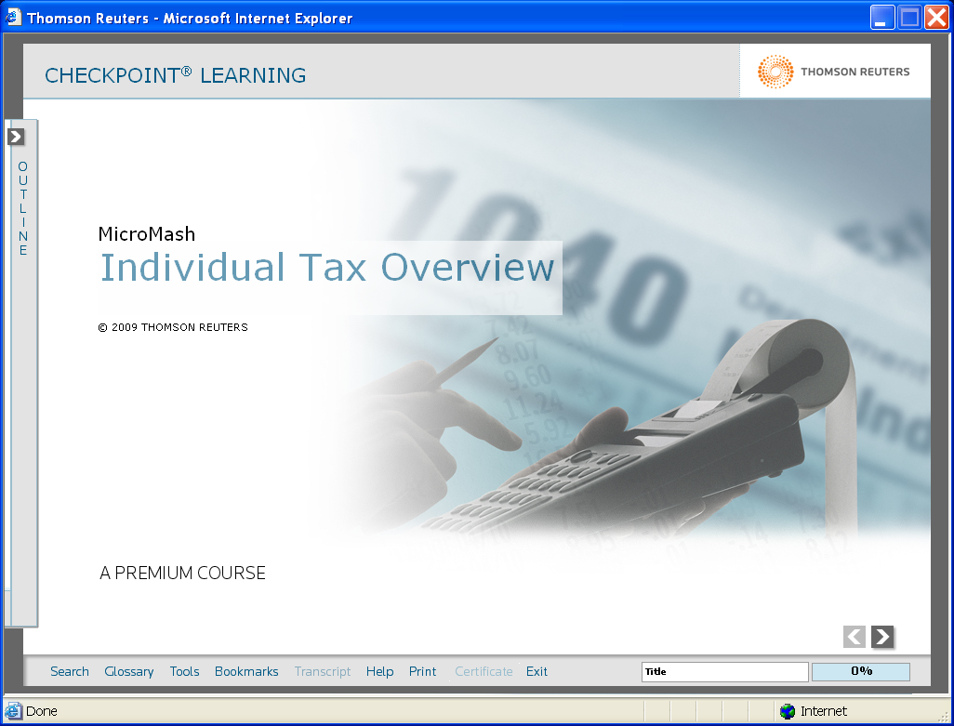

- Easier to navigate interface is more intuitive and contains more features (reveals course status, prints transcripts, provides tools such as calculators, links to forms and websites;
- Graphics, media and interactivity keep learners involved in the training exercises;
- Learning objectives have been linked to activities and questions; aligned to Bloom’s Taxonomy, to build critical thinking and problem-solving abilities;
- Inclusion of realistic exercises using actual forms, use of calculators and websites help with transference of concepts to real world activities;
- Learner interest and motivation maintained through wider variety of multiple-choice questions;
- Optional “Notes” sections allow learners to bypass basic information or drill-down to details as needed. This self-directed feature also helps keep screens shorter and cleaner and less intimidating for learners (reduces scrolling lengthy screens).
- Audio and video segments highlight new or difficult concepts so learners can focus more easily on them and repeat them if necessary; and
- Case studies and problem-based scenarios encourage learners to work with concepts in context of business situations, using calculators and the actual workpapers and other forms they use in their day-to-day jobs.

Checkpoint Learning: International Course Examples
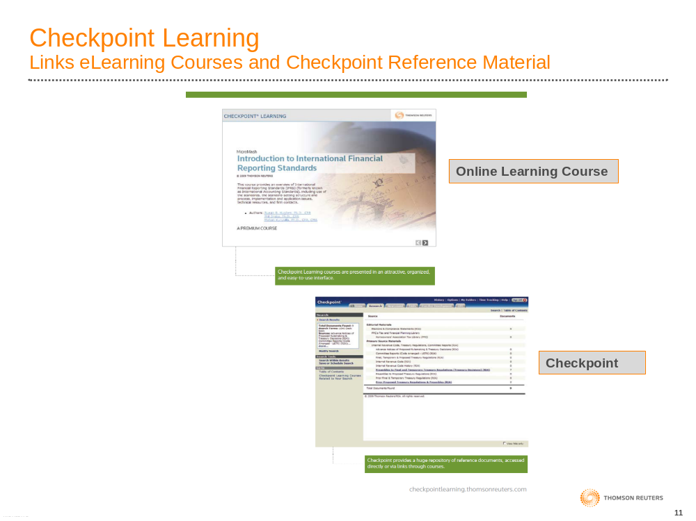
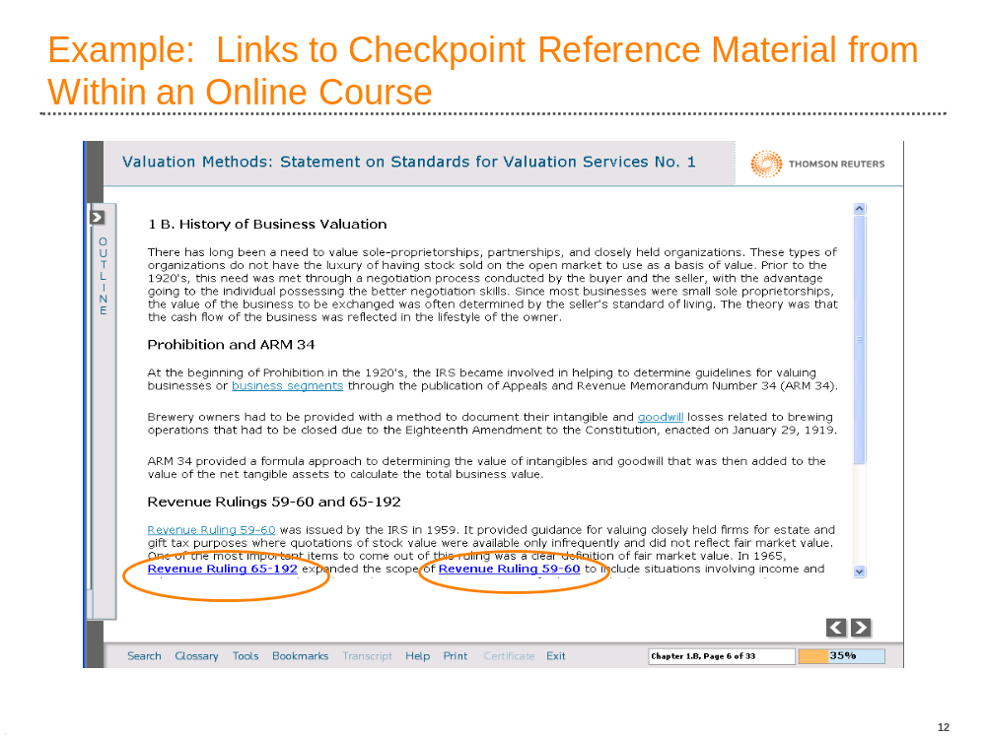

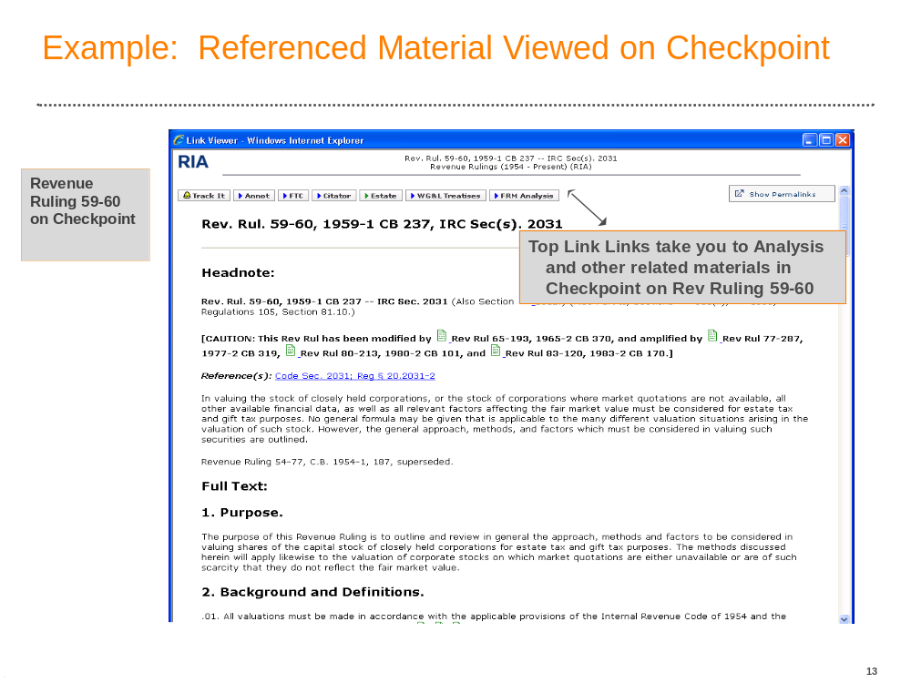

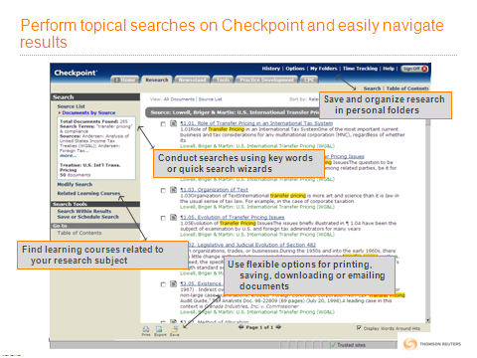
Checkpoint Learning Approach for IRS LMSB International Agents

Thomson Reuters Tax and Accounting instructional design specialists, international subject experts and editors recently reviewed the current International Revenue Agent training curriculum at the request of LMSB’s learning and Education team. Highlights of the recommended blended approach follow.

Blended learning is the practice of using multiple delivery formats to teach a single topic or course. The types of delivery formats may include two or more of the following:

- Online learning (eLearning)
- Webinars (virtual learning)
- Live (instructor-led)
- Book-based (self-study)

Each format has inherent strengths and optimal times and reasons for its use. Self-study formats are used to master basic skills and build understanding of baseline understanding. Group events are used to foster participation in activities and give learners the opportunity to ask questions and learn from others.

Why Use Blended Learning?
People learn in different ways. What works for one person may not work for another. In order to keep the instruction exciting and the learners engaged, a variety of delivery formats is utilized. A change of pace enhances interactivity and encourages active participation. Different activities engage different types of critical thinking skills in addition to retention and comprehension, thus providing a better opportunity to apply concepts to on-the-job activities. In short, blended learning is used to achieve a specific instructional purpose.
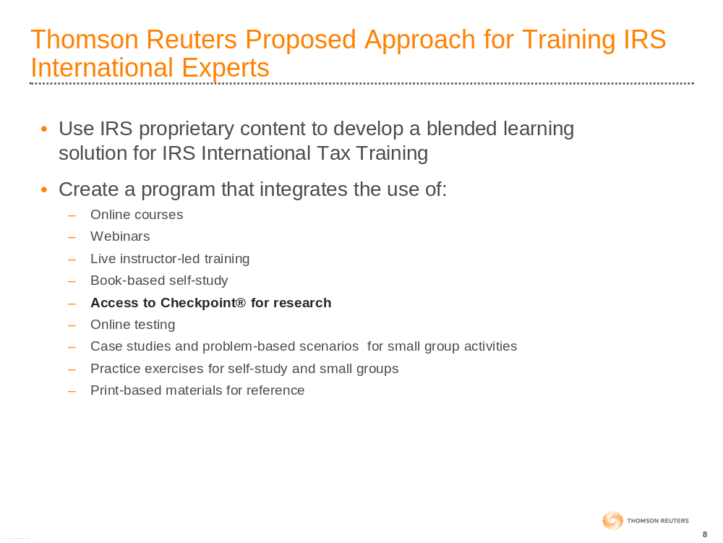

Thomson Reuters/IRS Learning Partnership

Thomson Reuters has provided IRS high quality online training in tax, accounting and related subjects through the MicroMash line of courses for nearly 20 years. The current contract was extended another 5 years in 2007 through August 2012 and provides more than 200 courses for IRS.

Over the years, Thomson Reuters has collaborated with IRS and completed several customized learning projects. Our history is built on a mutual desire for excellence in learning and performance. Here is a summary of custom courses designed to meet unique IRS requirements.
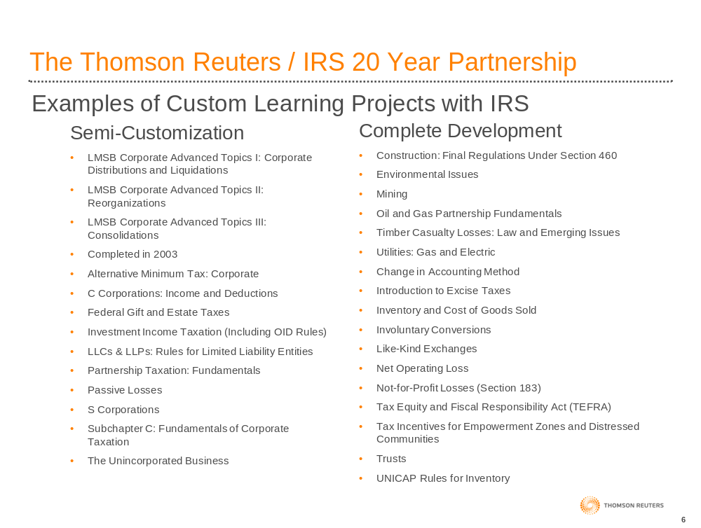

Custom Course Screen Shot Examples

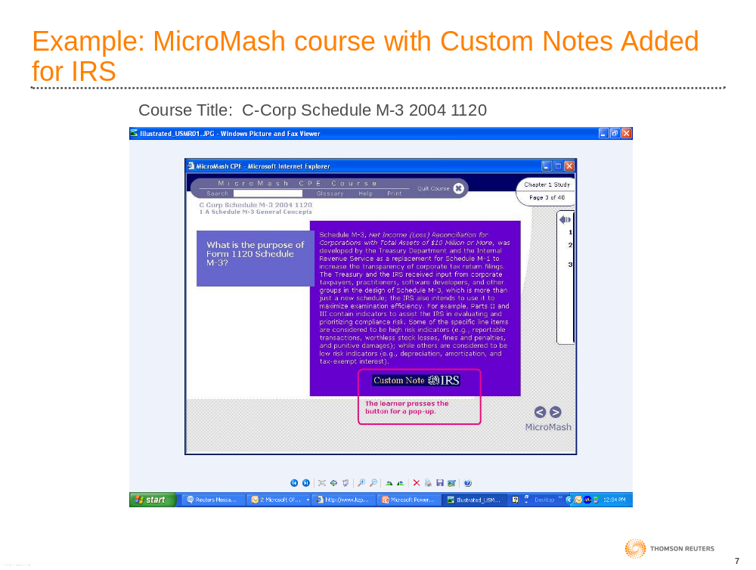

About Thomston Reuters

Thomson Reuters is the world’s leading source of intelligent information for businesses and professionals. With a winning combination of industry expertise and innovative technology, we deliver critical information for leading decision makers in the financial, legal, tax and accounting, scientific, health care, and media markets. With headquarters in New York, Thomson Reuters employs more than 50,000 people in 93 countries.
http://thomsonreuters.com/
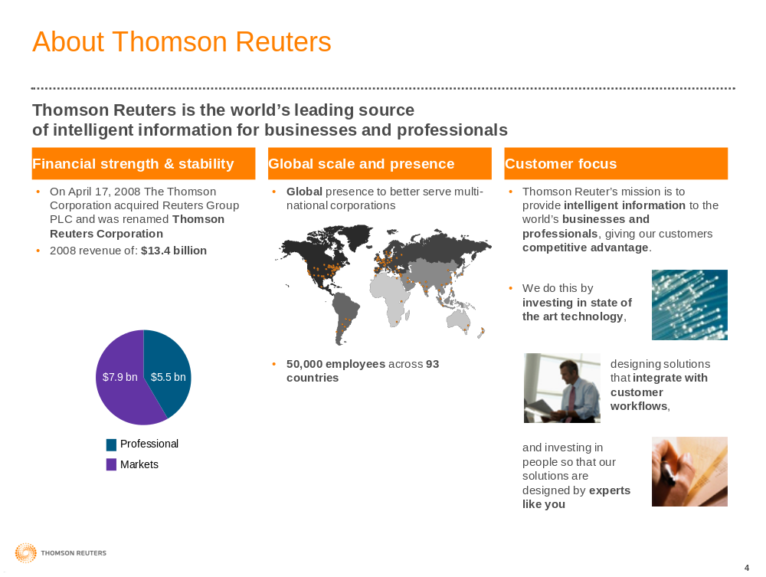

About The Tax and Accounting Business

The Tax & Accounting business of Thomson Reuters is the leading provider of technology and information solutions, CPE and Training, and integrated tax compliance software and services to professionals in accounting firms, corporations, law firms, and government.
Tax & Accounting delivers software and Web-based products and services that provide CPA firms and corporations with business automation solutions to help with tax compliance, firm management, client services, and corporate compliance. Our integrated information-based solutions for research and guidance, workflow efficiency, and training to help professionals across all market segments with decision support, knowledge management, routine task automation, and staying current on best practices, trends, current events, and new laws and regulations.
Key products and brands include Checkpoint, RIA, PPC, WG&L, MicroMash, PASS Online, AuditWatch, Gear Up, ONESOURCE, and the CS Professional Suite among many others. Tax & Accounting employs more than 4,000 individuals in various locations around the world.
Tax & Accounting’s Federal clients include the IRS, GAO, U.S. Tax Court, Joint Committee on Taxation, Senate Finance Committee, FDIC, DOL, SEC, and many others.
http://www.thomsonreuters.com/business_units/tax_accounting/

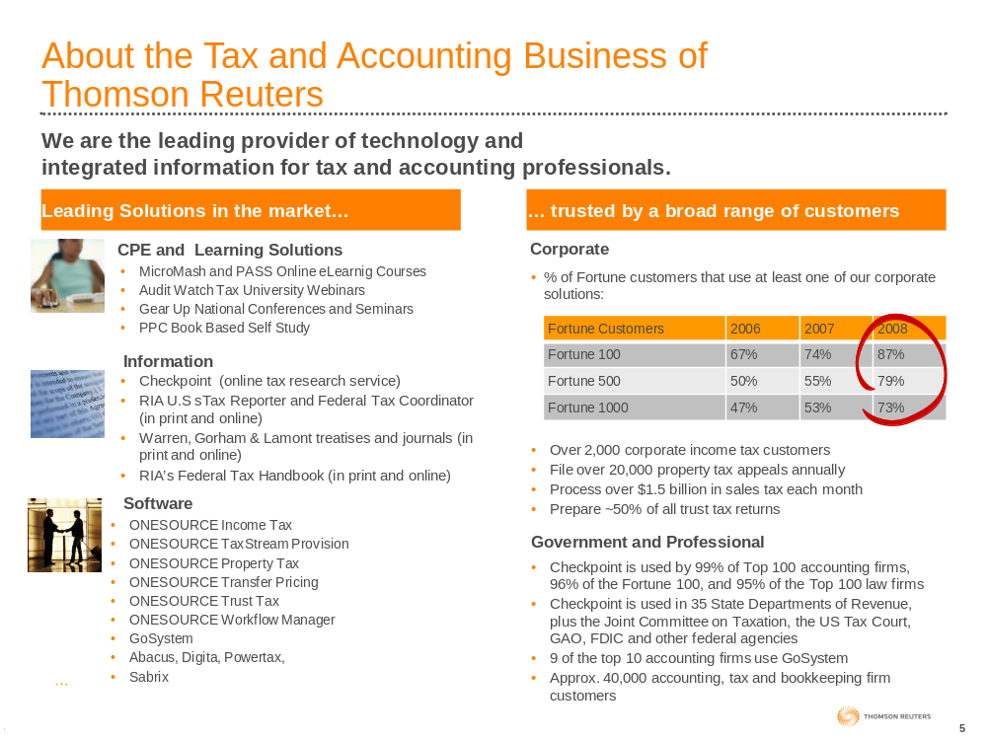

Third Party Content: Content from third party providers BNA, IBFD, Orbitax, Towers Perrin and Interactive Data Corporation can be integrated on the Checkpoint platform by special request. Please contact Ruth Apelt for more details.

